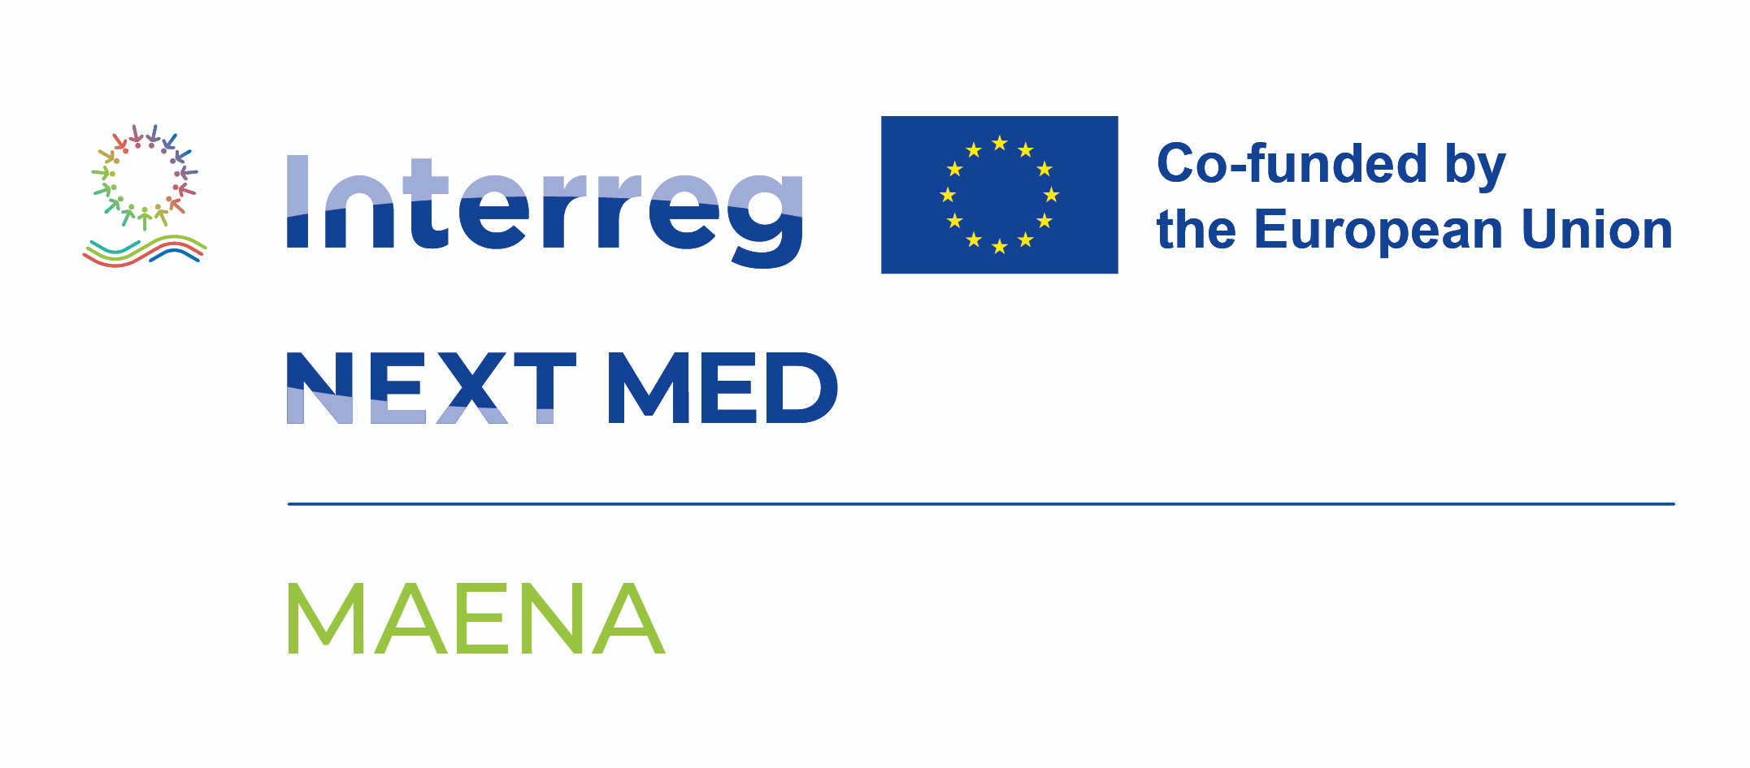
CIHEAM Bari – Mediterranean Agronomic Institute of Bari
Valenzano (BA), Italy

MAENA project
Replenishing the sMall wAter cyclE towards a more resilieNt Agriculture
Interreg NEXT MED Programme 2021–2027 – Project code: A_T_2.3_0285 – CUP: C63C25000970007

ANNEX B
Letter of commitment
Call for participation – Support for farmers in the Puglia region to optimise on-farm water use
To:
CIHEAM Bari – Mediterranean Agronomic Institute of Bari
Via Ceglie 9, 70010 Valenzano (BA), Italy
Attn. Director / Coordinator of the MAENA project
Subject: Letter of commitment under the MAENA Call for Participation – Apulia region

1. Identification of the undersigned

To be completed in full by the applicant or by the legal representative of the applicant entity. The information below shall be consistent with the data provided in the Application form (Annex A).
Personal details (applicant or legal representative)
Surname
Name
Date of birth |  |  | Place of birth
Tax code (Codice fiscale) |  |  | Identity document no.

Capacity in which the undersigned signs
(Tick one option — same as in the Application form, Section 2.1)
☐ Individual farmer (signing on own behalf)
☐ Legal representative of the applicant entity (specify legal name and role below)

Applicant entity (only if signing as legal representative)
Legal name (denominazione)
VAT number (Partita IVA) |  |  | Tax code (Codice fiscale)
Registered office (sede legale)
Role of the undersigned

Reference to the application
Group preference declared in the Application form (Annex A, Section 1):
☐ Group 1 – On-farm solutions and DSS deployment
☐ Group 2 – Training and access to resources

2. Recitals

The undersigned, in the capacity declared above (hereinafter the “Applicant”),
-having read in full the Terms of Reference of the MAENA Call for Participation issued by CIHEAM Bari;
-having understood the objectives, methodology, expected benefits and obligations of the support mechanism described therein;
-being aware that this Letter of commitment is an integral part of the application package required under Section 6.4 of the Terms of Reference;
-being aware that the support is fully funded by CIHEAM Bari through the Interreg NEXT MED Programme, with no financial contribution required from the Applicant;

Hereby declares to fully accept the obligations of selected beneficiaries set out in Section 8 of the Terms of Reference and undertakes the commitments listed in Section 3 below.

3. Commitments

The Applicant, conditional upon being selected as a beneficiary and upon signature of the beneficiary agreement with CIHEAM Bari, undertakes the following commitments for the full duration of the MAENA project (three years from the signature of the beneficiary agreement).
3.1 General commitments (Group 1 and Group 2)
1. to participate actively in the training and dissemination activities organised under the project, in accordance with the schedule communicated by CIHEAM Bari;
2. to provide CIHEAM Bari with accurate farm-level information necessary for the project (including, as relevant, crop, soil, pest management, irrigation, and yield data), under the confidentiality terms set out in the beneficiary agreement;
3. to acknowledge the support of the MAENA project and of the Interreg NEXT MED Programme in any communication, dissemination or promotional activity related to the intervention on the farm, in compliance with the visibility requirements of the Programme;
4. to notify CIHEAM Bari without undue delay of any event that may affect the fulfilment of the obligations set out in the beneficiary agreement, including changes in the legal status of the Applicant, in the legal access to the cultivated land, or in the productive structure of the farm;
5. to refrain from using the deliverables, training materials and any equipment provided by the project for purposes other than those agreed with CIHEAM Bari and consistent with the objectives of the MAENA project.

3.2 Additional commitments for Group 1 (on-farm solutions and DSS deployment)
The following commitments apply only if the Applicant is selected as a Group 1 beneficiary.
6. to host on the farm, for the full duration of the project, the sensor network and the Decision Support System for irrigation management in the locations agreed during the design phase;
7. to allow CIHEAM Bari staff and contractors to access the farm for the installation, configuration, maintenance and inspection of the equipment, and for data collection and monitoring activities, with reasonable advance notice agreed between the parties;
8. to safeguard the health and safety of CIHEAM Bari staff and contractors accessing the farm, in compliance with applicable national and EU health and safety provisions; in particular, to inform CIHEAM Bari in advance of any application of plant protection products on the plots involved in the intervention, to respect the re-entry intervals indicated on the product labels before allowing access, and to communicate any other site-specific hazards (including the operation of farm machinery, the presence of livestock, recently-fertilized areas, open wells or irrigation reservoirs) that may affect the safety of the personnel accessing the farm
9. to provide the necessary logistical conditions for the proper functioning of the equipment, including access to the field, electrical power supply where applicable, internet connectivity (where available on the farm), and a secure storage area for sensitive components;
10. to operate the irrigation system in accordance with the indications provided by the DSS to the extent compatible with farm management, and to record any deviation in the farm logbook for monitoring purposes;
11. to make the farm available, on a reasonable and pre-agreed basis, for organised exchange visits with other MAENA beneficiaries, project partners and stakeholders, in coherence with the dissemination activities of the project;
12. to take reasonable care of the equipment installed on the farm, and to refrain from removing, modifying or transferring it without the prior written authorisation of CIHEAM Bari.

3.3 Additional commitments for Group 2 (training and access to resources)
The following commitments apply only if the Applicant is selected as a Group 2 beneficiary.
13. to attend the training modules made available under the MAENA project and to provide the feedback requested by CIHEAM Bari for monitoring purposes;
14. to engage constructively in the SWCR Hub network and in the related stakeholder activities, where invited.

4. Term and conditions

This Letter of commitment becomes effective upon submission of the application package and remains valid until the earliest of the following events:
(i) notification by CIHEAM Bari that the Applicant has not been selected as a beneficiary or has been placed on the reserve list without subsequent activation;
(ii) written withdrawal of the application by the Applicant, communicated to CIHEAM Bari before signature of the beneficiary agreement.

The Applicant acknowledges that the present Letter of commitment is not in itself a beneficiary agreement and does not in itself create financial obligations for CIHEAM Bari. The terms, conditions and detailed obligations of the support will be set out in the beneficiary agreement to be signed by the selected applicants.
The Applicant retains the right to withdraw the application before signing the beneficiary agreement, by means of a written notification addressed to CIHEAM Bari, without any penalty.

5. Final declaration and signature

The undersigned declares that the information provided in this Letter of commitment is true and accurate, and confirms the commitments set out in Section 3, conditional upon being selected as a beneficiary and upon signature of the beneficiary agreement with CIHEAM Bari.
The undersigned acknowledges that the personal data provided in this Letter will be processed in accordance with the privacy information notice (Annex D) attached to the Call.
Place | Date | Signature of the applicant / legal representative

